UNDOCUMENTED BLACK IMMIGRANTS: A FRAMING ANALYSIS OF TWITTER COVERAGE

ABSTRACT
This study seeks to analyze the framing and portrayal of Undocumented Black immigrants. It is a public and noticeable issue that can't be disregarded. ​​With the growth of African immigrants increasing in the United States (Pew Research, 2017), and new immigration policies put in place in 2021 during the first year of President Biden’s presidency, this study investigates how undocumented black immigrants are portrayed particularly using twitter as a field of research. Using Framing theory and Agenda Setting this study employed the Brand watch examined tweets, mentions and any media traction on twitter from Jan 2020 to July 14, 2021.

INTRODUCTION
“Illegal immigrants,” “undocumented immigrants,” “unauthorized immigrants,” or something else entirely? The labels we use to refer to different classes of individuals are not merely neutral descriptors but often implicitly come with various associations or value judgments, which can, in turn, frame and influence political debates (Jonathan Kwan 2021). The use of proper words to define a group of people is extremely crucial to how the media portrays them and how they stand in matters of public opinion. The United States is waking up to radically evolving government policies that concern immigration thus the communication landscape is changing and so is framing.

BACKGROUND
Over the years, immigration has transformed the demographics of developed countries, including the United States, and has played a leading role in building what has become the most prosperous nation in the history of the world – With their indispensable contribution to America’s economy for centuries (Denhart, 2017). The number of foreign-born individuals in the United States has doubled since 1950; Immigrants make up over 40% of the U.S. workforce in industries like farming, fishing, and forestry, which contribute billions of dollars in taxes and contribute billions of dollars in taxes and add over a trillion dollars to the U.S. economy (American Immigration Council, 2019).
Black and undocumented immigrants face a unique struggle as they are caught in the intersection of being both black and immigrants two of the most historically oppressed demographics in the United States (Breanne 2017). Undocumented Black immigrants constantly live a life with fear with twice the trouble, with police and Immigration officers breathing down their neck almost simultaneously. (Geo 2018). Former President Trump and Democratic presidential candidate and President Joe Biden differ dramatically in their approaches to immigration policy. President Trump has focused mainly on creating a merit-based, or high-skill, immigration system and looks to continue the immigration agenda that has been a mainstay in his administration. Former Vice President Joe Biden would likely return to the immigration system of the Obama Administration and would relax the strict regulation so government resources and eventually citizenship would be available to all classes of immigrants (Isabel 2020)
With the election of Joe Biden, a democrat, immigration activists expected changes for the better. For example, since taking office, President Biden has
• Rescinded the ban on Muslim and African countries - The United States was built on a foundation of religious freedom and tolerance, a principle enshrined in the United States Constitution. Nevertheless, the previous administration enacted several Executive Orders and Presidential Proclamations that prevented certain individuals from entering the United States — first from primarily Muslim countries, and later, from largely African countries. Those actions are a stain on our national conscience and are inconsistent with our long history of welcoming people of all faiths and no faith at all (Biden, White House Proclamation 2021).
• Halted the construction of the border wall - immigrant rights activists energized by a new Democratic administration and majorities on Capitol Hill are gearing up for a fresh political battle to push through a proposed bill from President Joe Biden that would open a pathway to citizenship for up to 11 million people. The multimillion-dollar #WeAreHome campaign was launched Monday by national groups including United We Dream and the United Farm Workers Foundation. It starts with ads on Facebook and other social media to reach lawmakers and the constituents who can pressure them. “We are home,” a young woman’s voice declares in the first video spot showing immigrants in essential jobs such as cleaning and health care. “Home, even when they say we don’t belong.” (Wash. (APNews2021)
• DACA- Deferred Action for Childhood Arrivals (DACA) is a United States immigration policy that allows some individuals with unlawful presence in the United States after being brought to the country as children to receive a renewable two-year period of deferred action from deportation and become eligible for a work permit in the U.S. To be eligible for the program, recipients cannot have felonies or serious misdemeanors on their records. Unlike the proposed DREAM Act, DACA does not provide a path to citizenship for recipients.^{[1][2]} The policy, an executive branch memorandum, was announced by President Barack Obama on June 15, 2012. U.S. Citizenship and Immigration Services (USCIS) began accepting applications for the program on August 15, 2012. In 2012, the Obama-Biden Administration created the Deferred Action for Childhood Arrivals (DACA) policy, which has allowed hundreds of thousands of young immigrants to remain in the United States, to live, study, and work in our communities. Nine years later, Congress has not acted to provide a path to citizenship for Dreamers.Yesterday’s Federal court ruling is deeply disappointing. While the court’s order does not now affect current DACA recipients, this decision nonetheless relegates hundreds of thousands of young immigrants to an uncertain future. The Department of Justice intends to appeal this decision to preserve and fortify DACA. And, as the court recognized, the Department of Homeland Security plans to issue a proposed rule concerning DACA soon. But only Congress can ensure a permanent solution by granting a path to citizenship for Dreamers that will provide the certainty and stability that these young people need and deserve. I have repeatedly called on Congress to pass the American Dream and Promise Act, and I now renew that call with the greatest urgency. It is my fervent hope that through reconciliation or other means, Congress will finally provide security to all Dreamers, who have lived too long in fear.

• Protection for Libyan and Haitian refugees According to UndocuBlack Network, Washington’s Buzzfeed News reported today that the Biden administration will redesignate Temporary Protected Status (TPS) for Haiti. TPS protects any Haitian immigrant in the U.S. on or before May 21, 2021, from deportations and provides them with work authorization. This move comes after years of concerted advocacy led by Black immigrants. The Trump administration stripped Haiti of its TPS status in 2017, after evidence emerged of racist motives behind the move.
However, not all are good news. Under the Biden-Harris administration, 1,800 Haitian refugees were deported on the first day of Black History month. According to Undocublack Nework, on this first day of Black History Month, as the nation pays tribute to the generations of African Americans who struggled and continue to struggle through anti-Black structural racism, discrimination and violence, an ICE deportation flight took off this morning to Haiti. This deportation, which follows a deportation January 28 to Jamaica, represents the latest in a long history of intentional abuses by immigration authorities against Black women, children and families who seek safety and security in the United States. Under the Trump Administration, deportation flights soared in the midst of the coronavirus pandemic, despite numerous reports that deportations put deported individuals at great risk of contracting the virus, as well as exported the virus to deporting countries who often lacked health and other infrastructure to deal with infection being carried on deportation flights. Moreover, “Title 42” (of the U.S. Code) expulsions have resulted in a complete border shut down under the pretext of public health, and denied most of the over 380,000 immigrants expelled under Title 42 in 2020 their right to state claim of fear of persecution or torture. Despite having a new administration, ICE continues to take advantage of the court-ordered temporary stay in President Joe Biden’s deportation moratorium, which a Texas judge extended on January 29 for an additional 14 days, until February 23.
Thus the #WeAreHome campaign was launched in recognition of the millions of undocumented immigrants who live, work, and contribute to the United States every day (MaketheroadNY, 2021) This strategy was in direct response to demand legalization of and ensure that leadership is doing everything in their power to provide immediate relief and protection to undocumented members in our community who have brought this country forward during its hardest moments.

FACTS OF THE CASE
The UndocuBlack Network is a multi-generational group led by and for currently and formerly undocumented Black immigrants to foster community, facilitate access to resources, and support people to thrive and live their fullest lives (UndocuBlack.org 2020). Founded in 2016, UndocBlack has quickly evolved from a volunteer-driven national gathering of undocumented Black immigrants to a key voice and advocate for Black immigrants. UndocuBlack has taken a leadership role in several major national campaigns, including the Defend our Dreams campaign and the fight of #BeyondTemporary for holders of Temporary Protected Status (TPS) and Deferred Enforced Departure, the latter resulting in the enactment of the Liberian Refugee Immigration Fairness Act in December 2019. [MDM1] It has also produced and disseminated timely and educational videos on the Dream Act and TPS to educate allies, including the Congressional Black Caucus (Unboundphilanthropy.org)

UNDOCUBLACK SOCIAL MEDIA Presence is relatively active use of social media, strong engagements and response to questions and queries. frames black immigration policy as top priority, connects and engages with anything that benefits immigration and policies surrounding it in general. follows organizations that do the same vital work and collaborates on different campaigns ultimately for the greater good. They excellent use of press releases on their websites alongside an existing following of 19,000 on twitter, 43,900 on Instagram as well as email - vast list of those that click call to action button, no actual statistics while Facebook has 11,972 people on its page.

LITERATURE REVIEW

According to Gyamfi (2021), Black immigrants are subject to many of the same issues as other immigrant groups. They require difficult to obtain documentation, they struggle with a tumultuous journey, and they are constantly afraid of interactions with law enforcement due to fear of deportation. On top of this, when they come to the United States they are also forced to deal with the inherent racism and anti-blackness of the US. Black immigrants are far more likely to face detention or deportation due to police interaction. The issue of separation of immigrant families tends to center around Latinx immigrants, but many black immigrants are separated from their families through incarceration, child and social services, and deportation and it is often overlooked. Even their journey to the U.S through Latin America is arguably more difficult with many not speaking Spanish and therefore being refused food, shelter, and medical care.

Black immigrants facing racial disadvantages
According to the Immigrant Learning Center, many black immigrants are faced with being in an outgroup for the first time. Often coming from countries in Africa where they are the ethnic majority, black immigrants can struggle with adapting to social settings in which they are underrepresented. This is especially present in social situations like school. They are even seen as an outgroup among immigrants as well (Tesfai, 2019). With much of the US immigration narrative centered around Latinx immigrants, as they are the overwhelming majority, issues of black immigrants can fall to the wayside. Their intersectionality makes things like learning English, for the 4 in 10 that do not speak it, much more difficult (Immigrant Learning Center, 2021). A 2015 Department of Education report stated that black English Language Learners perform worse in math and reading than black native speakers and other English Language Learners. Much of this can be attributed to black immigrants not fitting the stereotype of an immigrant non-English speaker. Many teachers also exhibit implicit bias, holding black students and non-native speakers to lower standards. With black non-English speakers belonging to both groups, they are duly affected (Immigrant Learning Center, 2021). Once migrating to the United States, the migrants must adjust to the US labor market, which might not benefit the migrants immediately.

According to the Immigrant Learning Center, black immigrants on average make $8,000 less per year than the typical American, and $4,200 less than the average immigrant. This is the case despite their education levels being on par with other immigrant groups, with African immigrants being the most educated of all immigrant groups. This is consistent with black Americans who on average make less money than their white counterparts working the same jobs (Immigrant Learning Center, 2021).

Black Caribbean immigrants are experiencing racial stress and it increases along with their time of residency. Case and Hunter theorized that “racial identity act as a complex filter for racial stimuli” (2014). As years go by, black Caribbean immigrants begin to share the same way of thinking as black Americans. They become more racialized and experience the same racial oppression and struggles as black Americans (Case & Hunter, 2014). Black immigrants’ makeup 10 percent of blacks in the United States (Tesfai, 2019). Although black immigrants have similar racial segregation patterns as Asian and Latinx immigrants, they are still the most segregated group (Tesfai, 2019).

Dreamers view on DACA
Undocumented students have a sense of belonging when attending school from kindergarten to the twelfth grade (Gonzales, Brant, Roth, 2020). As the undocumented youth begin to reach their adolescent years, their vulnerability begins to grow affecting their everyday lives. The sense of vulnerability begins to affect their adulthood as they are now facing the same constraints their parents have faced (Gonzales, Brant, Roth, 2020). With the DACA program, it allows a sense of lawful presence and belonging into American society for undocumented youth but when the DACA program is in question, they gain a sense of vulnerability and lost identity (Mallet-Garcia & Garcia-Bedolla, 2021).

In the research conducted by Mallet-Garcia and Garcia-Bedolla, they found that 22 out of their 65 Latinx, DACA recipient interviewees said they regret having applied for DACA. The uncertainty of DACA makes them feel more vulnerable for deportation since the government now has their personal information (Garcia & Garcia-Bedolla, 2021).

DACA recipients may not take their activism public or may participate less, due to fear of being exposed or deported (Getrich, 2021). To protect their identities, DACA recipients share their stories on their own terms. As a form of activism, DACA recipients are educating people in their everyday activities about immigration (Getrich, 2021). This form of activism allows for those with a citizenship status to be informed and become allies who support an immigration reform (Getrich, 2021).

Although the DACA program allows the access to a better-paying job, health care, drivers licenses, etc., it is not a permanent solution to citizenship. According to the FWD.us, in 2021, there are an estimated 1,888,000 dreamers in the United States, and approximately 100,000 immigrants arrived from Caribbean countries (2021).

Outgroups view on DACA and immigration
Most news outlets describe DACA and Dreamers in a positive outlook and how DACA is a way to protect migrants (Rendon, de Moya, Johnson, 2019). DACA recipients are not categorized as criminals since they have grown up and shared the American culture. However, the coverage of DACA recipients and its outlook tend to align with the audience viewpoints (Rendon, de Moya, Johnson, 2019). It was also discovered that even if English-language outlets speak positively about DACA, they too are more likely to focus on the negative aspects than Spanish speaking networks (Rendon, de Moya, Johnson, 2019).

Twitter is a quick and easy platform to express an opinion or share information. It is often used when expressing thoughts or information about immigration. In a study, it was discovered that anti-immigration tweets expressed cognitive rigidity (Grover, Bayraktaroglu, Mark, & Rho, 2019). Anti-immigration tweets have a higher rate of utilizing words of anger and negative emotion than pro-immigration tweets (Grover, Bayraktaroglu, Mark, & Rho, 2019).

RELEVANT THEORIES
Agenda setting theory (Maxwell McCombs and Donald L. Shaw) - Agenda-setting theory describes the “ability [of the news media] to influence the salience of topics on the public agenda.” That is, if a news item is covered frequently, the audience will regard the issue as more important. Mass media only shows the audience what it comprehends as an important issue. This was founded by journalist Walter Lippmann in the 1920's. Lippmann claimed that the influence of the media affects the presentation of the reports and issues made in the news that affects the public mind. The news reports make it so that when a particular news report is given more importance and attention than other news the audience will automatically perceive it as the most important news and information given to them. The priorities of which news comes first and then the next are set by the media according to how people think and how much influence it will have among the audience.

FRAMING THEORY
The concept of framing was first posited by Gregory Bateson in 1972. He defined psychological frames as a “spatial and temporary bounding of a set of interactive messages” (Bateson, 1972, p. 197) that operates as a form of metacommunication (Hallahan, 2008). Framing describes the practice of thinking about news items and story content within a familiar context. In essence, framing theory suggests that how something is presented to the audience (called “the frame”) influences the choices people make about how to process that information.
Framing is related to the agenda-setting tradition but expands the research by focusing on the essence of the issues at hand rather than on a particular topic. The basis of framing theory is that the media focuses attention on certain events and then places them within a field of meaning (Mass Communication Theory (Online), 2017). Entman’s (1993) definition of framing is the most widely accepted: “To frame is to select some aspects of a perceived reality and make them more salient in a communicating text” (p. 52). The definition is more focused on the “aspect of perceived reality,” on how the public take news coverage to shape their understanding of what is real. An immigrant group that has been affected by news frames in the negative way are the Latino immigrants. The most reported news in the media of Latino immigrants is often associated with crime, which gives room for Latinos to be perceived as criminals (Kim et al, 2011). The question of how media portrays immigrants has been examined by past research (e.g., Coutin & Chock, 1997; King, 2002; Lehrman, 2005), who found that the media coverage about immigrants is most likely to be portrayed negatively by being linked with bad behaviors and conduct (crime, violence, and other cases immigration policies). Although some studies have shown the other side of the media, portraying Latinos highlighting their strong family ties, or cultural pride, or remarkable faith. Also, for the African immigrants, portrayed as survivors, hard-working, religious, educated, and professionals in the fields (Donagher, Poulos, Liebert, & Davidson, 1975; Gunter, 1998).

METHODS
Twitter discussions with respect to the Undocumented black immigrants were gathered utilizing Brand Watch, a powerful social media research tool. Brand watch is a social media analytic tool that tracks billions of conversations happening online every day, including blogs, news, forums, videos, twitter, reviews, image, Facebook…etc., and allows brands and companies to understand consumer insights, trends, influencers, and brand perception. In this case, the software allowed the collection of diverse and highly useful information most of which was used in the analysis portion of this case study.

Tweets posted from January 20, 2020, to July 14, 2021, were gathered. First, conversations were identified by initiating a query that collected all original tweets, mentions and replies pertaining to the hashtags, #UndocuBlack, #ImmigrationisaBlackIssue, and #WeAreHome. This brought about an underlying example of 287 tweets.

ANALYSIS AND FINDINGS

LITERATURE ANALYSIS

The literature examined leads to the conclusion that black undocumented immigrants sit at the intersection of two historically oppressed groups in the United States. Their status as undocumented immigrants leave them vulnerable to deportation, familial separation, and labor abuse among other things. On top of this, their status as black people in America leaves them exposed to increased interactions with police and the penal system, which can then uncover their status as undocumented immigrants.

As immigrants, issues of deportation are incredibly prevalent. DACA is a potential solution, however many feels that it is more dangerous to apply and reveal your undocumented status. On top of this, DACA recipients heavily skew toward the latinx population. This makes weighing the risk for applying difficult as they must reveal their undocumented status, and the odds are they won’t get accepted.

Many facets of life are made more difficult for black immigrants because of their skin racial background. Education has begun to accept and cater to non-English speaking children of immigrants; however, most programs are created with Spanish speakers in mind. This makes it harder to get a proper education and plays a role in black immigrants making less money than the average American and the average immigrant.

TWITTER FINDINGS

Since most of the media in the United States is centered around immigrants from latinx countries, the unique struggles of black immigrants are often overlooked. With media coverage skewed away from black immigrants, people are starting to take to Twitter to organize aid. When examining trends in #wearehome, #undocublack, and #immigrationisablack issue we found that there were only 287 mentions between January 20, 2020 - July 14, 2021. The #wearehome carries little to no mention of black immigrants. While it is utilized by many different undocumented immigrant support groups, they all tend to cover exclusively latinx immigrants. Many of the posts that do mention black immigrants are asking for support for issues affecting both black and brown immigrants.

There are a small number of organizations dedicated solely to fighting for the rights of black undocumented immigrants. The organization Undocublack is leading the way with 19k followers. Although their fight is largely overshadowed by the larger Latinx immigration fight, according to Brand watch the general sentiment of tweets regarding black undocumented immigrants is more positive than negative despite the emotions of the tweets being sad. This shows that the general message is not coming from a place of lacking and unfairness. Rather, it is a movement focused on building traction and exposing the historical lack of concern for their cause. This is shown in the #immigrationisablackissue which was launched by Undocublack in 2020. The focus of this hashtag is to bring attention to and inform people about the struggles faced by black undocumented immigrants in the United States.

CONCLUSION

Facing oppression for both their racial identity and citizenship status, black undocumented immigrants should be much more represented in the fight for undocumented immigrants’ rights. Through our research, we wanted to determine how the situation of black immigrants differs from that of their Latinx counterparts, and how it is being framed in the media.

The reason that there is a difference in framing is a perfect example of the agenda setting theory in action. The media has chosen to focus their coverage of the issue almost exclusively from the perspective of latinx immigrants. Because of this, much of people’s knowledge of immigration is from the perspective of latinx immigrants, which negatively affects other immigrant groups as there is a lack of awareness of their unique problems. This has left black undocumented immigrants to take to digital activism to increase awareness for their struggles.

This case study is fascinating because we are watching a digital movement grow from its infancy. The framing of this movement is one that acknowledges the lack of awareness but uses it as an opportunity to inform the public. While the interactions with the movement on Twitter are still relatively small, it will be interesting to watch this movement grow and see how the mainstream media will react. This is a topic to keep tabs on as it will no doubt teach us about the trials of a grassroots digital activism movement, and the successful or unsuccessful practices involved. One day we may see black undocumented immigrants at the forefront of news discussion over the issue of immigration in the United States and we would have digital activism to thank.

REFERENCES
Case, A. D., & Hunter, C. D. (2014). Cultural Racism–Related Stress in Black Caribbean Immigrants: Examining the Predictive Roles of Length of Residence and Racial Identity. Journal of Black Psychology, 40(5), 410–423. https://doi.org/10.1177/0095798413493926

Getrich, C. M. (2021). “People Show Up in Different Ways”: DACA Recipients’ Everyday Activism in a Time of Heightened Immigration-Related Insecurity. Human Organization, 80(1), 27–36. https://doi.org/10.17730/1938-3525-80.1.27

Gonzales, R. G., Brant, K., & Roth, B. (2020). DACAmented in the age of deportation: navigating spaces of belonging and vulnerability in social and personal lives. Ethnic and Racial Studies, 43(1), 60–79. https://doi.org/10.1080/01419870.2019.1667506

Grover, T., Bayraktaroglu, E., Mark, G., & Rho, E. H. R. (2019). Moral and Affective Differences in U.S. Immigration Policy Debate on Twitter. Computer Supported Cooperative Work, 28(3), 317–355. https://doi.org/10.1007/s10606-019-09357-w

Mallet-García, M. L., & García-Bedolla, L. (2021). Immigration Policy and Belonging: Ramifications for DACA Recipients’ Sense of Belonging. The American Behavioral Scientist (Beverly Hills), 65(9), 1165–1179. https://doi.org/10.1177/0002764221996777

McEwan, Bree & Sobre-Denton, Miriam. (2011). Virtual Cosmopolitanism: Constructing Third Cultures and Transmitting Social and Cultural Capital Through social media. Journal of International and Intercultural Communication. 4. 252-258. 10.1080/17513057.2011.598044.

Rendon, H., de Moya, M., & Johnson, M. A. (2019). “Dreamers” or threat: Bilingual frame building of DACA immigrants. Newspaper Research Journal, 40(1), 7–24. https://doi.org/10.1177/0739532918814448

Tesfai, R. (2019). Double Minority Status and Neighborhoods: Examining the Primacy of Race in Black Immigrants’ Racial and Socioeconomic Segregation. City & Community, 18(2), 509–528. https://doi.org/10.1111/cico.12384
Simon, S. (2021, February 27). In The Story of U.S. Immigration, Black Immigrants Are Often Left Out. NPR. other. https://www.npr.org/2021/02/27/972056955/in-the-story-of-u-s-immigration-black-immigrants-are-often-left-out.
White, S. (2021, July 16). What Does it Mean to Be a Black Immigrant in the United States? > The Immigrant Learning Center. The Immigrant Learning Center.

EXHIBITS AND APPENDICES
https://www.ilctr.org/what-does-it-mean-to-be-black-immigrant-united-states/.

https://www.communicationtheory.org/agenda-setting-theory/

(2021, March 1). Dreamers by the Numbers. https://www.fwd.us/news/dreamers-by-the-numbers/

https://www.scu.edu/ethics/focus-areas/immigration-ethics/immigration-ethics-resources/immigration-ethics-blog/words-matter-illegal-immigrant-undocumented-immigrant-or-unauthorized-immigrant/?

https://unboundphilanthropy.org/undocublack/

https://undocublack.org/press-releases/2021/5/22/undocublack-network-haitian-tps-redesignation-is-a-lifeline-for-thousands-and-a-reminder-of-the-power-of-organizingnbsp

https://www.whitehouse.gov/briefing-room/presidential-actions/2021/01/20/proclamation-ending-discriminatory-bans-on-entry-to-the-united-states/
https://www.americanactionforum.org/insight/comparing-trump-and-biden-on-immigration/

https://www.whitehouse.gov

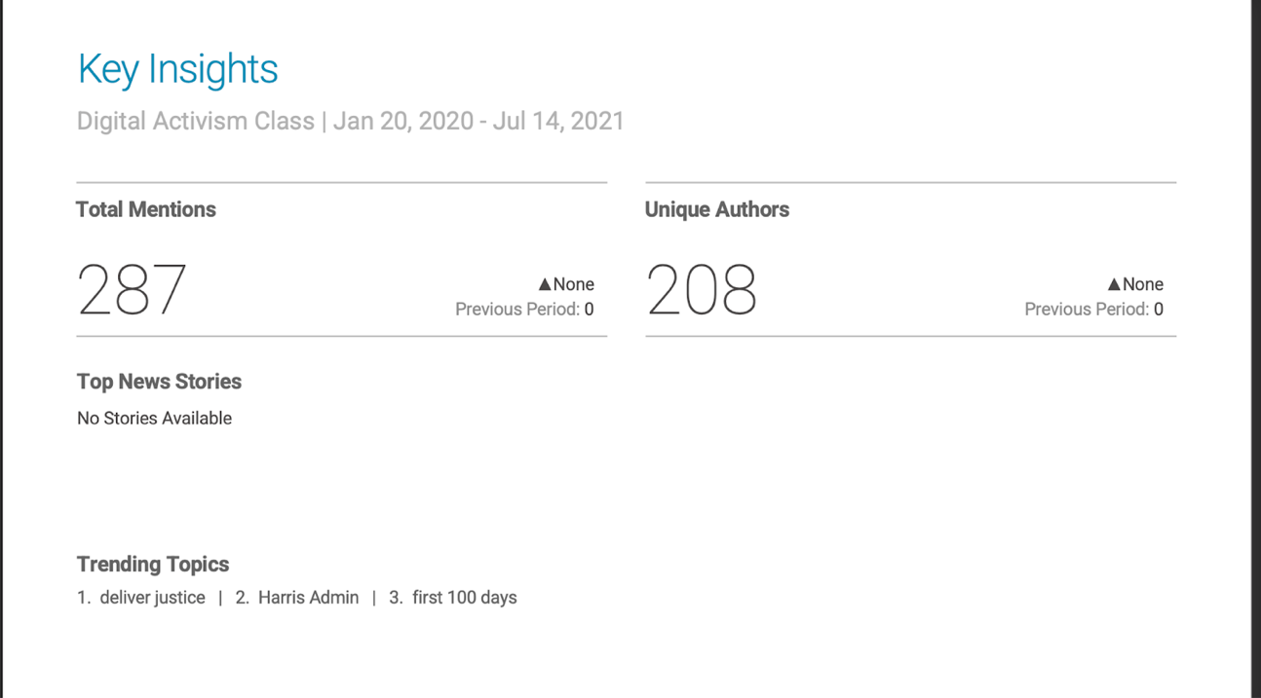

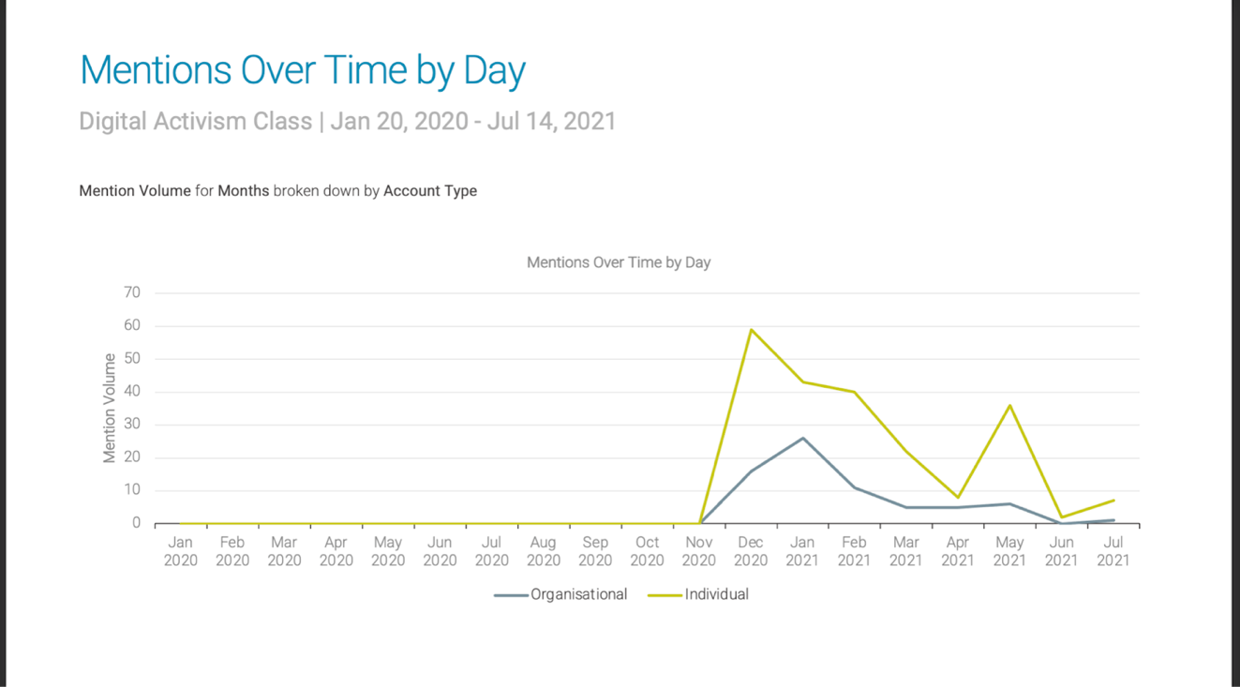

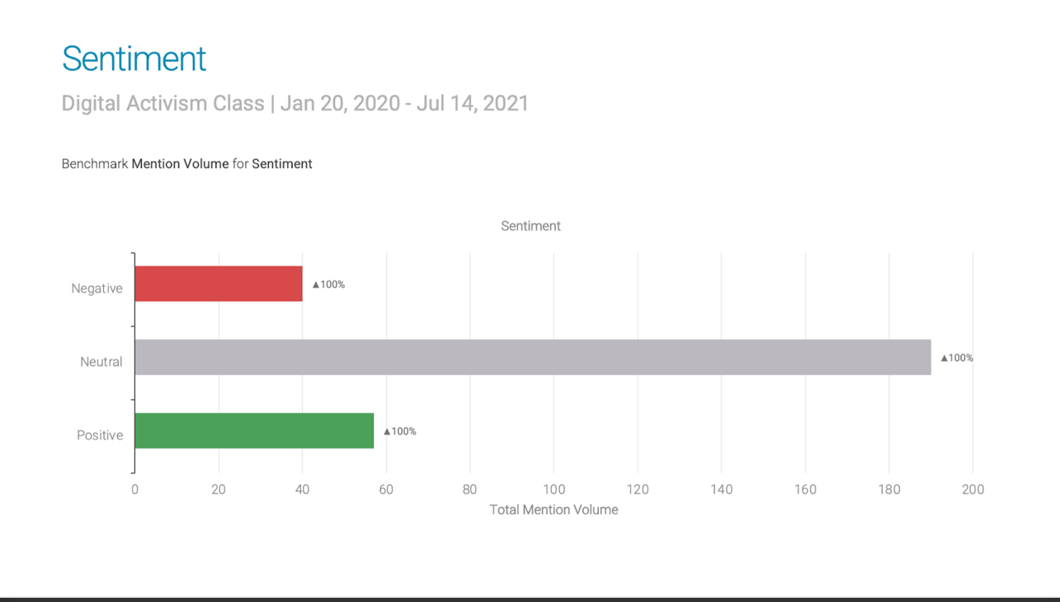

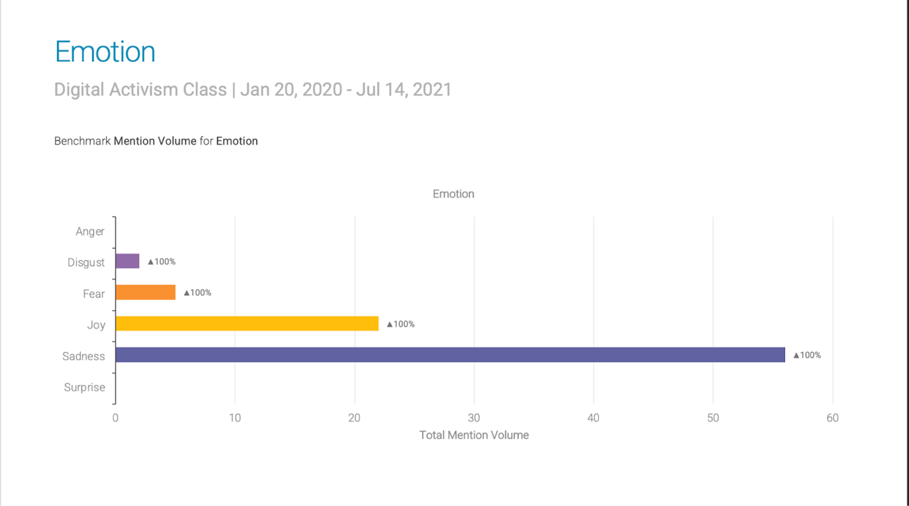

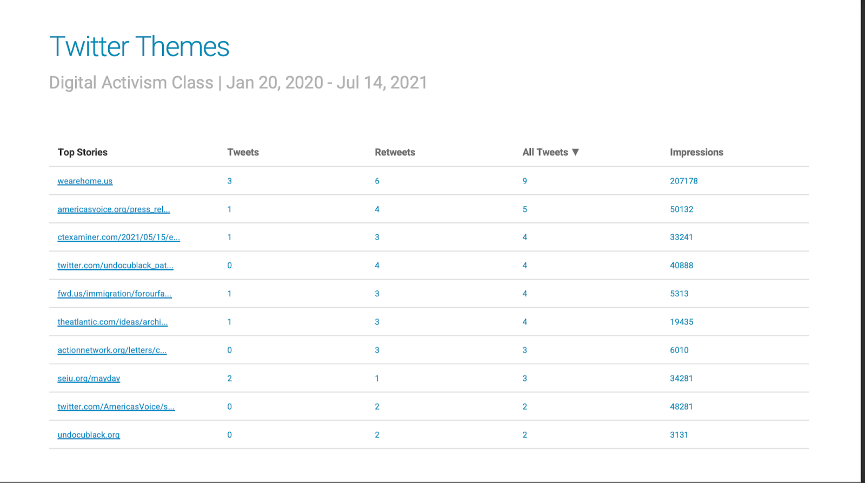

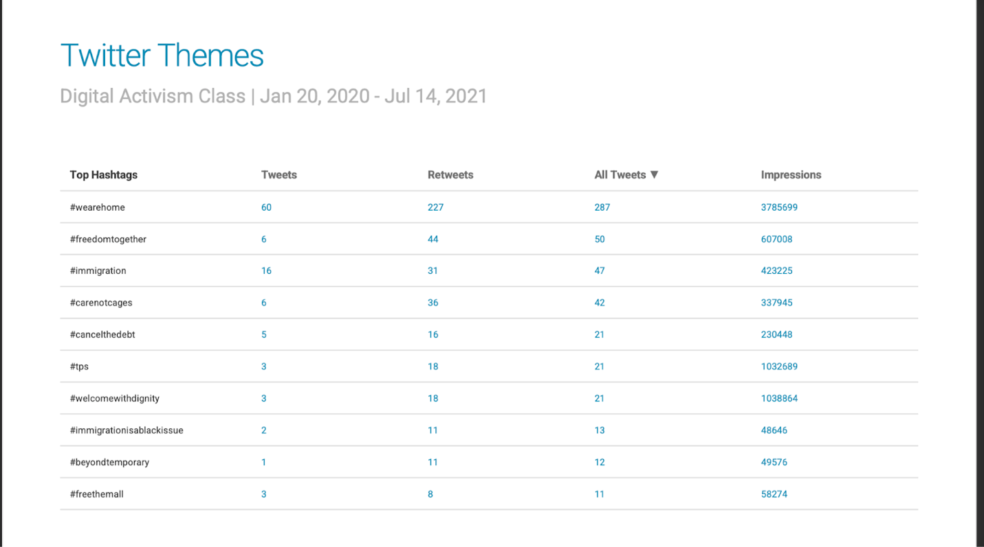

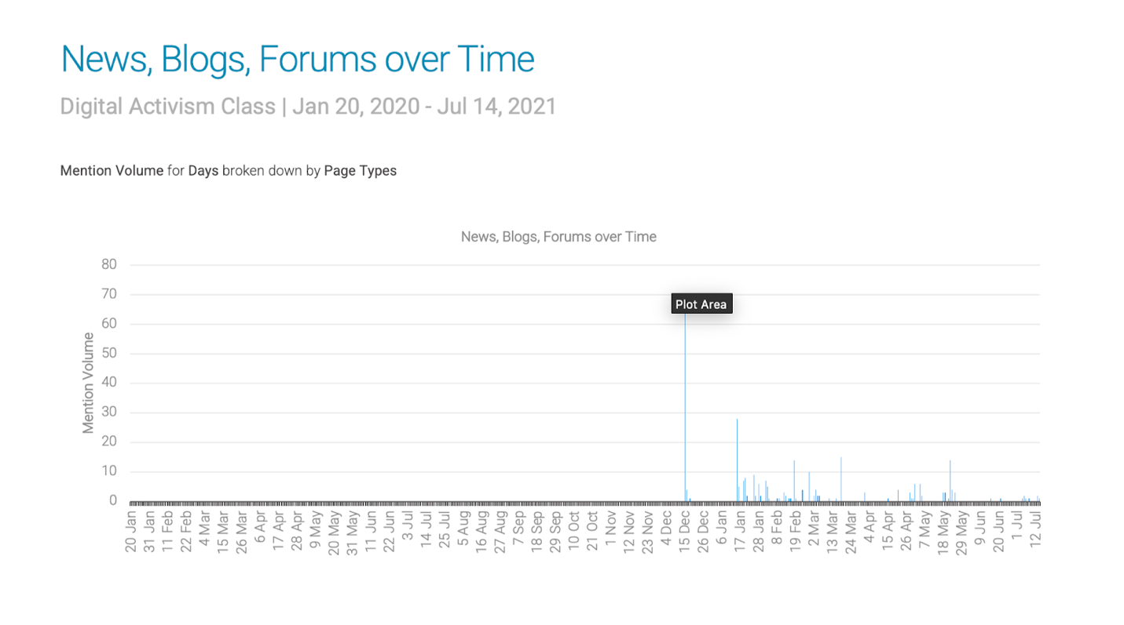

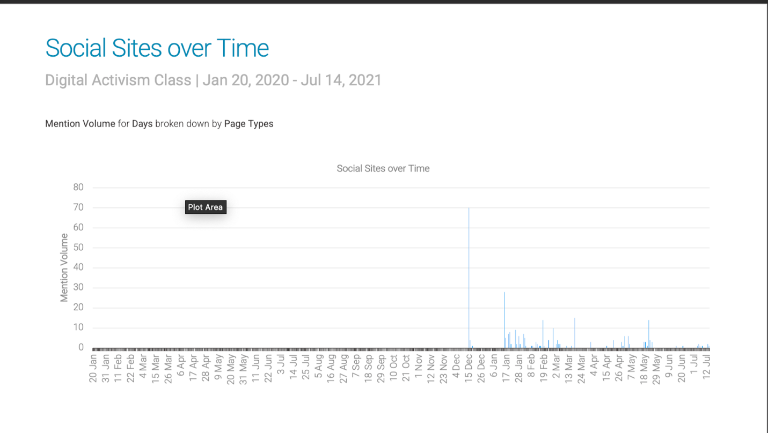

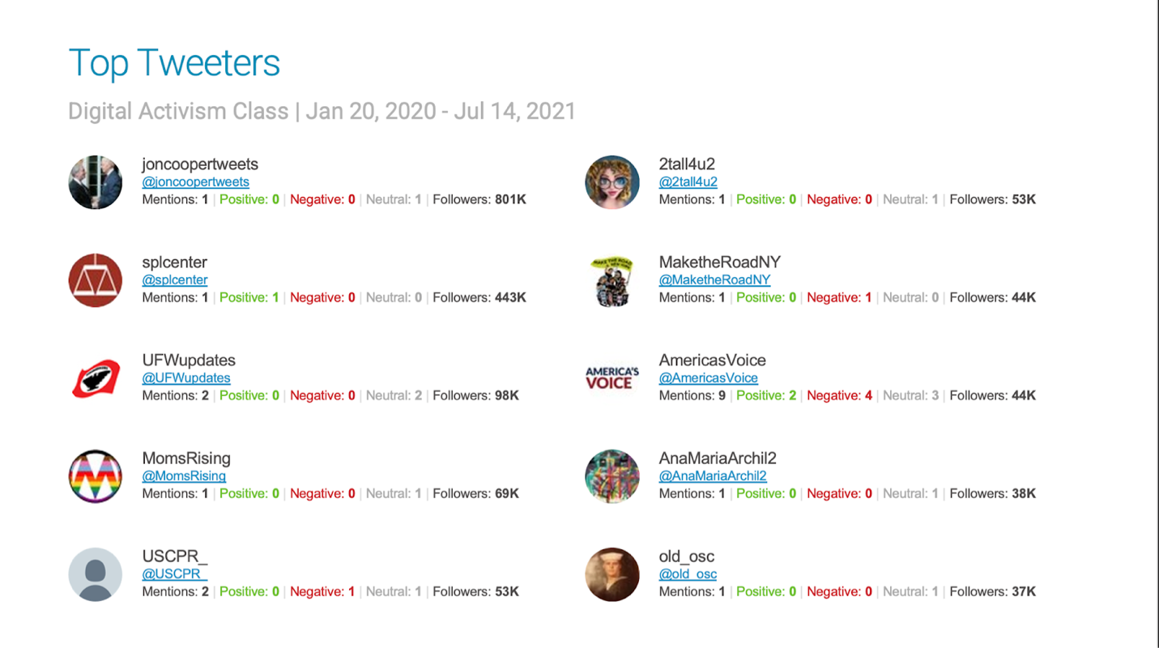

Table of Contents
Abstract 3
[Title Here, up to 12 Words, on One to Two Lines] 4
[Heading 1] 4
[Heading 2] 4
[Heading 3] 4
References 5
Footnotes 6
Tables 7
Figures 8

